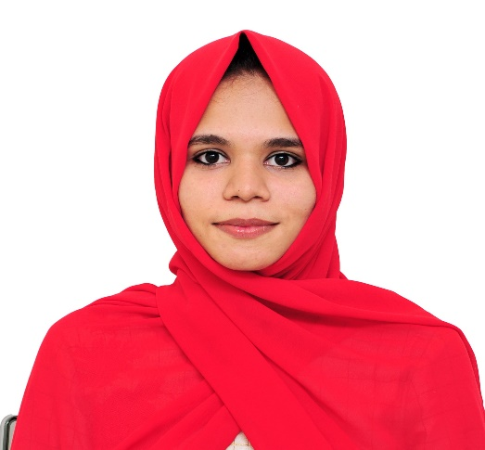

BABISHA SALEEM

Contact

**Address:**

Al falah City, Abu dhabi

**Phone:**

+971 544882355

**Email:**

[salimbabisha87@gmail.com](mailto:salimbabisha87@gmail.com)

**LinkedIn:**

#### https://www.linkedin.com/in/babisha-salim-4a0a09203

Languages

English (Advanced)

Hindi (Advanced)

Malayalam (Native)

Hobbies

* Travel
* Music
* Design

|  |  |
| --- | --- |
| Summary  Dedicated IT Support Engineer with a strong background in troubleshooting hardware, software and network issues. Experienced with Windows, MacOS, and Linux platforms. Proven ability to resolve technical issues quickly and effectively. Excellent communicator with a commitment to maintaining secure and optimized IT environments. |  |

Skill Highlights

|  |  |
| --- | --- |
| * Project management * Communication skills * Adaptability * HTML/CSS * Editor and IDE(Microsoft Visual Studio) * Team Work | * Creativity * Innovative * Focus on work * Coding Languages : PHP (Laravel), Java, C, C++ * SQL server |

Education

* Master of Computer Application: 2015-2018

**Calicut University.**

* Bachelor of Science: **Computer Science** – 2012-2015

**Calicut University**.

Work Experience

**IT SUPPORT ENGINEER**

Professional IT Solutions L.L.C

08/11/2019 – 15/09/2021

* Provided first-line and second-line support to end users, troubleshooting and resolving hardware, software and network issues across multiple platforms (Windows, macOS, Linux).
* Guided users on best practices and provided training on IT systems, including email, remote desktop tools, and enterprise applications to improve productivity.
* Monitored and maintained network and server health, managing system updates, antivirus protection, and backup procedures to ensure system security and availability.

Academic Projects

* Event Management System with 3D

(MCA - Main Project)

**Language** : PHP-Laravel, MySQL.

* Safe Kerala (MCA – Mini Project)

**Language** : PHP, ANDROID, MySQL.

* E-DINING (Bsc- Main Project)

**Language :** Java, Android, MySQL.